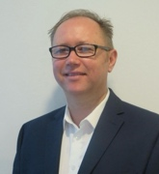

Meet Our
Ministerial Team

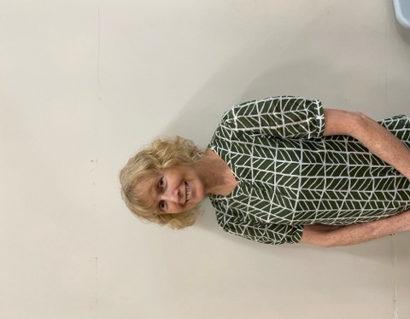

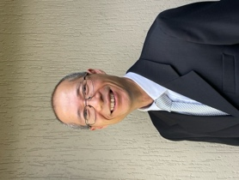
Svetlana Li, Bible Worker (Chinese language speaker)
0407 634 689 | svetali8102@yahoo.com

Gayl Fong, Bible Worker
0414 505 146 | gaylfong@icloud.com
Head Elder | Ben Chapman | 0418 965 310
Head Shepherdess | Gayl Fong | 0414 505 146
Head Deacon | Tim Carson | 0491 132 496
Head Deaconess | Marilene Stevenson |  | 0401 628 909
Copyright manager | copyright@waitarachurch.org.au
Audio Visual Leaders | Jeandre & Marnitz | 0452 368 901
 | av@waitarachurch.org.au
Bulletin & Runsheet Editor | Phillip Dickson | 0407 887 587
Send bulletin items to: | bulletin@waitarachurch.org.au
Bulletin Cut-Off Time: | Tuesday 7pm SHARP

e-Giving
Please use the QR Code to do
Your e-Giving for the Tithes
And Offering to this Church.
Daniel Przybylko, Senior Pastor
0418 525 437 | DanielPrzybylko@adventist.org.au
Robert Zhang, Associate Pastor
0415 048 264 | robertzhang@adventist.org.au
9:20am | Sabbath School
9:30am | Bible Study
11:00am | Divine Service

We extend a warm welcome to you on this beautiful Sabbath morning. If you are visiting us for the first time, we pray that your time with us will be blessed as we worship together.
Feel free to visit us again.
Welcome to
Waitara Church

Upcoming Divine Service Speakers
- 23 May Denison Grellmann
- 30 May Youth
- 06 June Pr Robert Zhang (Communion)

Church Lunch Rostered Hosts
- 16 May No Lunch
- 23 May Gayl’s group
- 30 May Darko’s group
- 06 June No Lunch (Communion)

May Board Meeting
The next church board meeting will be held on May 25.

Cooking Class - Sunday, 17 May, 2.30 pm - 4:00 pm:
The session will focus on plant-based meals designed to help lower cholesterol and support weight management. Enjoy demonstrations of simple, energising recipes, with taste testing, take-home recipes and informative handouts provided by Nutritionist Kaysie Vokurka. To book, phone or text 0419 015 798 or https://bit.ly/4sXw9ZB Venue: Chesham Community Hall.

Men’s outing to train museum
Boys’ day out to the train museum in Thirlmere on 31 May from 9am to 3:30pm. Meet at Waitara church at 7:30am to leave at 8am sharp. See Andy or call 0404 924 181 for details. For the men coming to join the outing, could you please provide Andy with a $30 deposit per person for the train fare so the group can travel together.

Sacred concert this afternoon
Health and Hope PNG presents a Sacred Concert in support of fundraising for an upcoming mission trip to Papua New Guinea. Join us this afternoon here at Waitara Church from 3:00 pm. Light refreshments and cookies will be available for purchase after the concert.
SABBATH SCHOOL
Song Service |  | Kaysie Vokurka
Bible Study #7  Practical Prayer |  | By Classes
World Mission Report  Field with Bells |  | Report from Tanzania
Welcome |  | Tahlia Hughes
SS Feature  Adventist World Radio |  | Tahlia Hughes
Mission Offering & Prayer |  | Tahlia Hughes
Hymn #369  (Verses 1st & last only) |  | Bringing in the Sheaves
DIVINE SERVICE
Announcements |  | Joy Carey
Song Service |  | Kaysie Vokurka
Welcome |  | Denis Carey
Hymn of Praise #340 |  | Jesus Saves
Children’s Story | Pr Daniel Przybylko
Tithes & Offerings |  |  | SPD Comprehensive Health Ministry
Special Item |  | Abram Andalis
Invocation |  | Now Dear Lord . . .
Communal Prayer |  | Geena-Rose Burton
Scripture Reading |  | Philippians 3:13-14  Charlotte
Message |  | Hand on the Plough  Pr Daniel Przybylko
Benediction |  | Pr Daniel Przybylko
Hymn of Dedication #517 |  | My Faith Looks Up To Thee
Conclusion &  Benediction Hymn |  | Denis Carey

16 May 2026
Message synopsis
The Apostle Paul calls our spiritual journey a ‘race’. We are called to “press on” to “reach forward” and "not look back" as we help others along the way, believing that our victory is sure in Jesus Christ.
Bill Gates sermon "The Sunday Keeping Christian's Massive Dilemmas" notes can be obtained if people email Bill requesting the notes to blessingsandwarnings@gmail.com

Prayer in the Vestry. Everyone welcome.

Sabbath morning prayer time between 8:45 – 9:15 am. Venue: Chinese study group Room if joining in person or remotely via Zoom Meeting ID: 983 3681 8132; Passcode: 2077W Prayer Focus: "Waitara Ministries"

Wednesday Mid-Week Prayer Meeting
Please join us for Prayer & Reflection Time this Wednesday 20th May on Zoom @ 8:00 to 8:30pm Zoom Meeting ID: 983 3681 8132; Passcode: 2077W

3ABN Interview Programs. (airing 17/5/26):
3ABN Now can be viewed on V.A.S.T. ch 109, online at www.3abnaustralia.org.au, & on the free 3ABN phone App, every Sunday at 7:00pm, Tues., 7:00pm, Wed., 9:00am, & Sabb., 2:00am. This week’s guest is Dr Erika Puni (Testimony). Next Sunday––Pr David Klinedinst.

Offerings Next Sabbath:
Divine Worship | Local
Sabbath School | Mission
Sunset Times
This evening | 5:02pm
Next Friday 22/05/2026 | 4:58pm

